Easy build kit for using your 3.3v 8Mhz Arduino Pro Minis with StuartsProjects breadboard friendly modules
Can be used with StuartsProjects breadboard friendly plug in boards that are available for modules based on lora devices such as the RFM95 or DRF1278. The completed product can then be used for a range of lora based GPS tracker and other sensor applications.
The kit does not include the Arduino Pro Mini, these are easy to find at very low cost on several e-commerce sites, be sure to get the right type, see the pictures of an assembled board below or the build instructions here Build Instructions.
The board has an 2 x 8way pin header expansion connector that allows devices such as GPSs, I2C sensors, switches and displays to be connected. A JST lead for a battery can be fitted. The kit contains the components that allow the Arduino to read the battery voltage.
Additional components can be fitted, some are surface mount, that expand the capability of the board; a 16Kbit or 64Kbit FRAM, PCF8563 real time clock, DS18B20 temperature sensor and a MOSFET to power down devices attached to the expansion connector.
There are numerous example sketches and lora based applications for this board in this library;
SX12XX-lora-library
These are the parts that come with the kit;
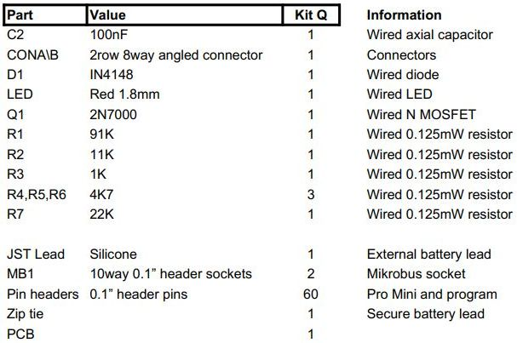

This board was used to test the many Arduino example programs for the SX1261, SX1262, SX1268, SX1272, SX1276, SX1278, SX1280 and SX1281 lora devices that are supported by the SX12XX library linked to above.

